**OreSat Deployable Antennas**

*Project Contract*

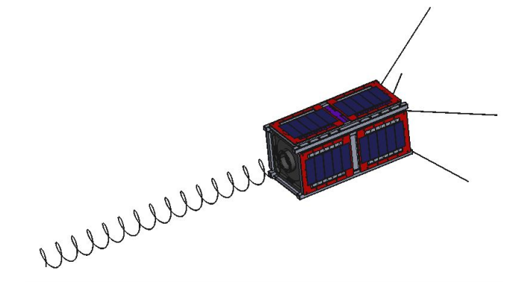

**Team Members**

*Calvin Young*

*Shivani Nadarajah*

*John George*

*Paijanne Jones*

*Justin Burris*

**Sponsors**

*Andrew Greenberg*

*Glenn LeBrasseur*

**ME 492**

*Gerald Recktenwald*

*26 January 2018*

**Project Objective:**

To design, test, and manufacture the communication antennas and deployment systems for Oregon’s first satellite (OreSat) by June 29th, 2018, to be integrated into Portland State Aerospace Society’s (PSAS) main satellite, with help from the Oregon Space Grant Consortium (OSGC) to cover the associated $2000 projected cost.

**Client Requirements:**

OreSat will have two deployable antennas: a canted turnstile array and a high-gain helical antenna. The former, a common omnidirectional antenna used for communications on spacecraft in low Earth Orbit, is mission critical and top priority. Successful deployment ensures ground station communication, a requirement for triggering the satellite’s de-tumble sequence which allows the helical antenna to be deployed and pointed at Earth. The helical antenna, designed to operate in the range of 2200 MHz to 2500 MHz, enables the satellite’s secondary and tertiary missions: high school STEM outreach and space-based climate research.

**Primary and Secondary Client Requirements:**

* Turnstile antenna communicates with ground control to enable primary missions
  + Comes online quickly in order to enable basic communications
* Helical antenna communicates with handheld receivers to enable secondary missions
  + Has sufficient gain to reach handheld stations
  + Has a reasonably narrow bandwidth
* Both antenna systems deploy reliably and repeatedly
  + Turnstile antennas are arrayed at appropriate angles
  + Helical antenna deploys to appropriate pitch
  + Antennas can be shown to work on launch day with a high degree of certainty
* Both antenna systems can withstand the harsh launch and orbital environments
  + Antennas do not prematurely deploy
  + Antennas and deployment systems survive the vibration of launch vehicle
  + Deployment mechanisms function in low-earth orbit
  + Antennas do not deform excessively during attitude control
* Both complete antenna systems fall under budget limitations
  + Minimizes the mass of all subsystems
  + Stays within electrical constraints of power system
  + Uses a reasonably small portion of the financial budget
  + Fits within the designated area on the satellite
* Both complete antenna systems meet regulatory and service provider requirements
  + Complies with specifications for 2U CubeSat
  + Meets safety standards imposed by NASA

After initial interviews with the client to establish the scope of the deployable antenna project, including line-item precedence, continued engagement in weekly meetings, discussions, and updates with the client, and/or associated PSAS team-members, will ensure progress, research, and prototype designs follow designated specifications and coordinate with other evolving satellite systems.

**Table 1**: Importance values assigned to the client’s primary requirements.

|  |  |
| --- | --- |
| Communication with ground control | 11 |
| Communication with handheld receivers | 7 |
| Antenna systems deploy reliably, repeatedly | 10 |
| Systems withstand the harsh launch and orbit environments | 7 |
| Systems fall under budget limitations | 5 |
| Systems meet regulatory requirements | 7 |

**Performance Metrics:**

The turnstile antenna should take less than an hour to deploy in order to secure baseline communications with the ground station promptly. The helical antenna can be deployed within a week, allowing for careful and controlled decompression of the helix. Each antenna must be deployed in a stable, controlled manner to avoid additional, unnecessary oscillation.

Both antennas and deployment systems must be able to withstand the harsh environment of low Earth orbit, including: exposure to a hard vacuum (without outgassing), unmitigated radiation, and temperature cycles between -40 and +125 degrees Celsius. Both antenna systems must also be able to sustain the range of vibration and mechanical stress during launch without damage or premature deployment. Additionally, the systems must be able to operate after storage for up to six months.

The mechanical requirements imposed by the client are limited: the material chosen must comply with the electrical requirements of the antenna: the supporting and deployment structure must not interfere with the communications; the antennas must come to rest in the correct, predetermined orientation. Far more rigid are the mechanical specifications outlined by the CubeSat Design Specifications (CDS) from Cal Poly. Of primary concern are the spatial and dimensional limitations. The antennas, prior to deployment, must pack tightly within a specified volume.

OreSat is an open-source, DIY project. All work shall be well-documented and publicly accessible.

Failure is not an option.

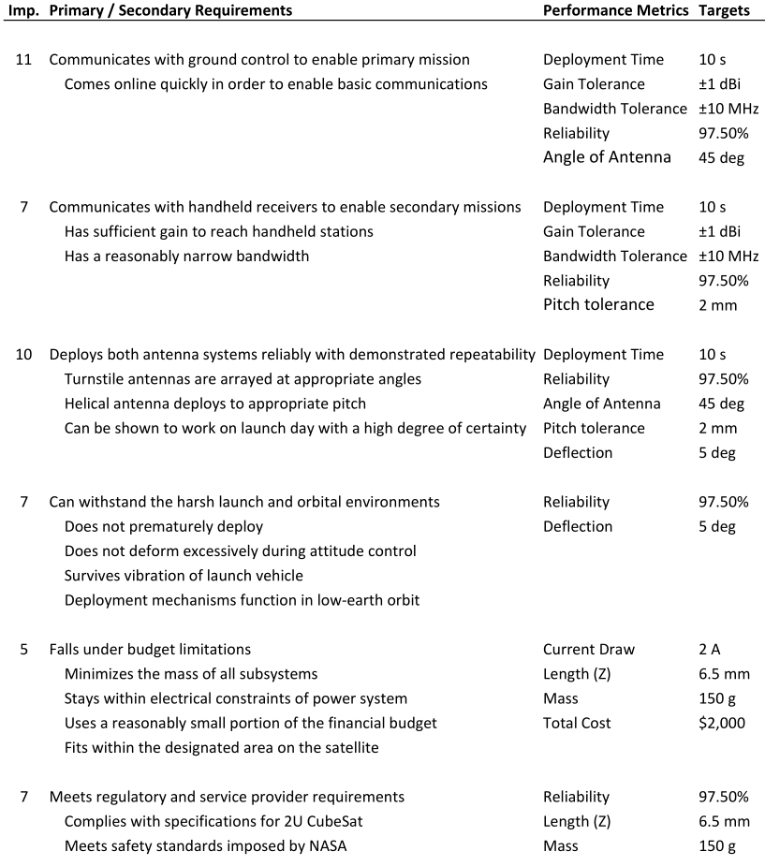

**Figure 1**: Performance metrics for each primary requirement.

*\*Note: Many values for the performance metrics are estimates derived from ongoing research, and are subject to change and review.*

**Requirements Matrix:**

After identifying the primary, secondary, and performance-related requirements from the client interview process we have correlated the primary needs with all associated performance measures and represented them graphically in a requirements matrix (Figure 2). This has been done to illustrate and map the connection, rank of importance, and dependency of the various performance measures needed to successfully meet the established project guidelines.

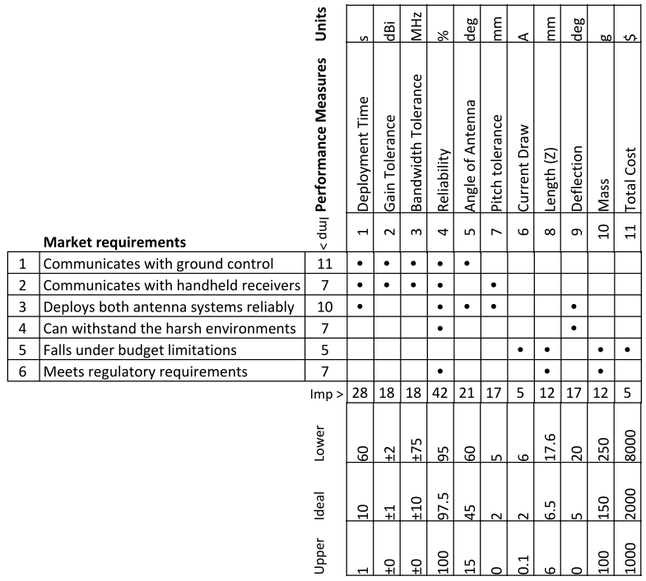

**Figure 2**: Requirements matrix linking client requirements to performance metrics.

**Deliverables:**

* Ongoing Research
  + To be presented and discussed in weekly meetings
  + To be clearly documented and organized for future reference as OreSat continues into its final stages of development

* *Preliminary* antenna and associated deployment system prototypes
  + Including: CAD models, theory, research, and design decisions
  + Analysis, testing and results
  + Presented to client for demonstration, review and revision (date: *)
* *Secondary* antenna and associated deployment system prototypes
  + Including: CAD models, theory, research, and design decisions
  + Thorough analysis, testing and results
  + Presented to client for demonstration, review and revision (date: *)
* *Final* flight-ready helical, and turnstile antenna with associated deployment systems fully integrated into OreSat structure
  + Including: Verified analysis and testing to ensure reliability
  + (date: *)
* Complete open-source documentation on GitHub and Google Drive, including:
  + CAD models (SolidWorks)
  + Theory, research, and design decisions
  + SOPs for antenna construction
  + SOPs for antenna flight preparations
  + Full reliability reports

**Commitment and Consent:**

By signing the contract, the undersigned agree to the guidelines, procedures and expectations included in this document.

**Team Members**

|  |  |  |
| --- | --- | --- |
| Calvin Young | Paijanne Jones | Justin Burris |
| John George | Shivani Nadarajah |  |

**Sponsors**

Andrew Greenberg Glenn LeBrasseur